EXPERIMENT 7
Create XML file to store student information like Enrolment Number, Name, Mobile Number, Email id.
Index.xml
<?xml version="1.0" encoding="UTF-8"?>
<?xml-stylesheet type="text/xsl" href="#studentXSLT"?>
<students>
<student>
<enrollment>1001</enrollment>
<name>Rahul Sharma</name>
<mobile>9876543210</mobile>
<email>rahul@example.com</email>
</student>
<student>
<enrollment>1002</enrollment>
<name>Anjali Verma</name>
<mobile>9123456780</mobile>
<email>anjali@example.com</email>
</student>
<student>
<enrollment>1003</enrollment>
<name>Amit Singh</name>
<mobile>9988776655</mobile>
<email>amit@example.com</email>
</student>

<student>
<enrollment>1004</enrollment>
<name>Neha Gupta</name>
<mobile>9012345678</mobile>
<email>neha@example.com</email>
</student>
<student>
<enrollment>1005</enrollment>
<name>Rohit Kumar</name>
<mobile>9098765432</mobile>
<email>rohit@example.com</email>
</student>
<student>
<enrollment>1006</enrollment>
<name>Pooja Mehta</name>
<mobile>9871234560</mobile>
<email>pooja@example.com</email>
</student>
<student>
<enrollment>1007</enrollment>
<name>Karan Malhotra</name>
<mobile>9812345670</mobile>
<email>karan@example.com</email>
</student>
<student>
<enrollment>1008</enrollment>
<name>Simran Kaur</name>
<mobile>9823456781</mobile>
<email>simran@example.com</email>
</student>
<student>
<enrollment>1009</enrollment>
<name>Arjun Patel</name>
<mobile>9834567892</mobile>
<email>arjun@example.com</email>
</student>
<student>
<enrollment>1010</enrollment>
<name>Priya Nair</name>
<mobile>9845678903</mobile>
<email>priya@example.com</email>
</student>
<!-- Embedded XSLT -->
<xsl:stylesheet id="studentXSLT" version="1.0"
xmlns:xsl="http://www.w3.org/1999/XSL/Transform">
<xsl:template match="/">
<html>
<head>
<title>Student Catalog</title>
<style>
body {font-family: Arial, sans-serif; background-color: #f4f6f8;}
h2 {text-align: center; color: #333;}
table {
border-collapse: collapse;
width: 80%;
margin: 20px auto;
background-color: #ffffff;
}
th {
background-color: #4CAF50;
color: white;
padding: 10px;
}
td {
padding: 10px;
text-align: center;
}
table, th, td {
border: 1px solid #ddd;
}
tr:nth-child(even) {
background-color: #f2f2f2;
}
tr:hover {
background-color: #ddd;
}
footer {
margin-top: 30px;
text-align: center;
padding: 10px;
background-color: #f2f2f2;
border-top: 1px solid #ccc;
}
</style>
</head>
<body>
<h2>Student Information Catalog</h2>
<table>
<tr>
<th>Enrollment No</th>
<th>Name</th>
<th>Mobile</th>
<th>Email</th>
</tr>
<xsl:for-each select="students/student">
<tr>
<td><xsl:value-of select="enrollment"/></td>
<td><xsl:value-of select="name"/></td>
<td><xsl:value-of select="mobile"/></td>
<td><xsl:value-of select="email"/></td>
</tr>
</xsl:for-each>
</table>

<!-- Footer Added -->
<footer>
<p><strong>Name:</strong> Prabhat Krishna</p>
<p><strong>Enrollment No:</strong> 02596302723</p>
</footer>
</body>
</html>
</xsl:template>
</xsl:stylesheet>
</students>

OUTPUT

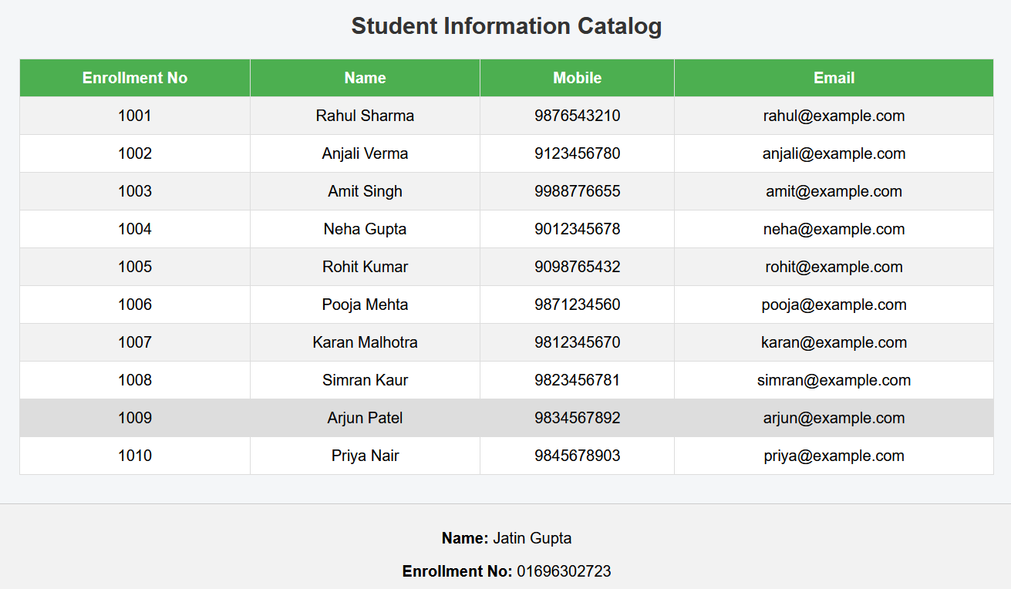

EXPERIMENT 8
Write a PHP script to read data from txt file and display it in HTML table (the file contains info in format Name: Password: Email).
Index.php
<!DOCTYPE html>
<html>
<head>
<title>User Data</title>
<style>
body {
font-family: Arial, sans-serif;
}
table {
border-collapse: collapse;
width: 60%;
margin: 20px auto;
}
th, td {
border: 1px solid black;
padding: 8px;
text-align: center;
}
th {
background-color: #f2f2f2;
}
footer {
margin-top: 30px;
text-align: center;
padding: 10px;
background-color: #f2f2f2;
border-top: 1px solid #ccc;
}
</style>
</head>
<body>
<h2 style="text-align:center;">User Information</h2>
<table>
<tr>
<th>Name</th>
<th>Password</th>
<th>Email</th>
</tr>
<?php
$file = "data.txt";
if (file_exists($file)) {
$lines = file($file, FILE_IGNORE_NEW_LINES | FILE_SKIP_EMPTY_LINES);

foreach ($lines as $line) {
$data = explode(":", $line);

if (count($data) == 3) {
echo "<tr>";
echo "<td>" . htmlspecialchars($data[0]) . "</td>";
echo "<td>" . htmlspecialchars($data[1]) . "</td>";
echo "<td>" . htmlspecialchars($data[2]) . "</td>";
echo "</tr>";
}
}
} else {
echo "<tr><td colspan='3'>File not found!</td></tr>";
}
?>
</table>
<footer>
<p><strong>Name:</strong> Prabhat Krishna</p>
<p><strong>Enrollment No:</strong> 02596302723</p>
</footer>
</body>
</html>
OUTPUT

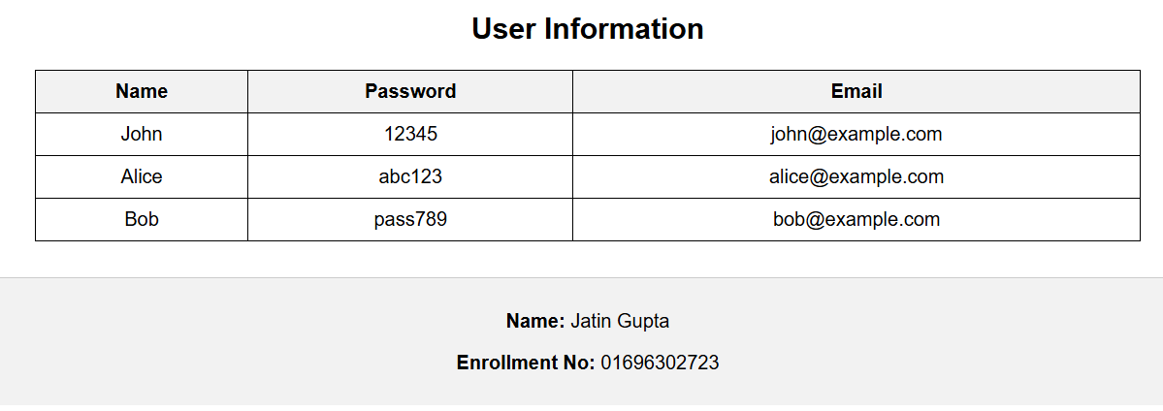

EXPERIMENT 9
Write a PHP Script for login authentication. Design an HTML form which takes username and password from user and validate against stored username and password in file.
Index.php
<!DOCTYPE html>
<html>
<head>
<title>Login Page</title>
<style>
body {
font-family: Arial;
background-color: #f4f4f4;
}
.login-box {
width: 300px;
margin: 100px auto;
padding: 20px;
background: white;
border: 1px solid #ccc;
text-align: center;
}
input {
width: 90%;
padding: 8px;
margin: 10px 0;
}
button {
padding: 8px 15px;
background: #4CAF50;
color: white;
border: none;
}
.error {
color: red;
}
.success {
color: green;
}
footer {
margin-top: 30px;
text-align: center;
padding: 10px;
background-color: #f2f2f2;
border-top: 1px solid #ccc;
}
</style>
</head>
<body>
<div class="login-box">
<h2>Login</h2>
<form method="post">
<input type="text" name="username" placeholder="Enter Username" required><br>
<input type="password" name="password" placeholder="Enter Password" required><br>
<button type="submit" name="login">Login</button>
</form>

<?php
if (isset($_POST['login'])) {
$username = $_POST['username'];
$password = $_POST['password'];
$file = "data.txt";
$valid = false;
if (file_exists($file)) {
$lines = file($file, FILE_IGNORE_NEW_LINES | FILE_SKIP_EMPTY_LINES);
foreach ($lines as $line) {
list($stored_user, $stored_pass) = explode(":", $line);
if ($username === $stored_user && $password === $stored_pass) {
$valid = true;
break;
}
}
if ($valid) {
echo "<p class='success'>Login Successful ✅</p>";
} else {
echo "<p class='error'>Invalid Username or Password ❌</p>";
}
} else {
echo "<p class='error'>User file not found!</p>";
}
}
?>
</div>
<!-- Footer -->
<footer>
<p><strong>Name:</strong> Prabhat Krishna</p>
<p><strong>Enrollment No:</strong> 02596302723</p>
</footer>
</body>
</html>
OUTPUT

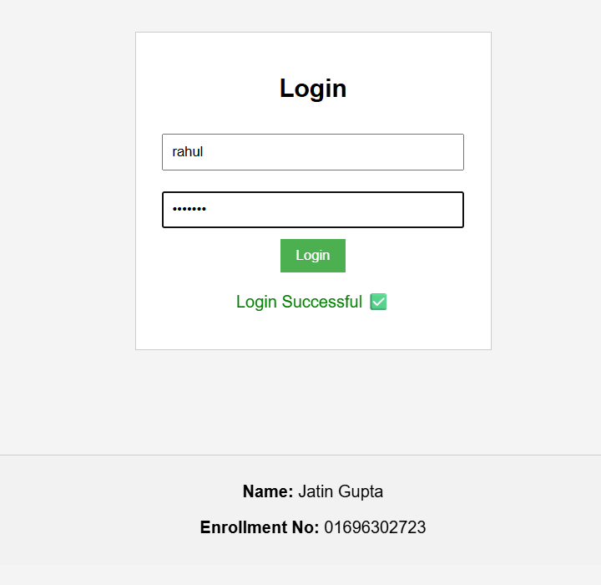
EXPERIMENT 10
Write PHP Script for storing and retrieving user information from MySQL table:
a. Design a HTML page which takes Name, Address, Email and Mobile No. from user (register.php)
b. Store this data in MySQL database / text file.
c. Next page display all user in HTML table using PHP (display.php)
register.php
<!DOCTYPE html>
<html>
<head>
<title>Register</title>
<style>
body { font-family: Arial; background:#f4f4f4; }
.box {
width: 350px;
margin: 50px auto;
padding: 20px;
background: white;
text-align: center;
border: 1px solid #ccc;
}
input, textarea {
width: 90%;
padding: 8px;
margin: 8px 0;
}
button {
padding: 8px 15px;
background: green;
color: white;
border: none;
}
footer {
margin-top: 30px;
text-align: center;
padding: 10px;
background: #eee;
}
</style>
</head>
<body>
<div class="box">
<h2>User Registration</h2>
<form method="post">
<input type="text" name="name" placeholder="Name" required><br>
<textarea name="address" placeholder="Address" required></textarea><br>
<input type="email" name="email" placeholder="Email" required><br>
<input type="text" name="mobile" placeholder="Mobile" required><br>
<button type="submit" name="submit">Register</button>
</form>

<?php
if(isset($_POST['submit'])) {
$conn = new mysqli("localhost", "root", "", "userdb");
if ($conn->connect_error) {
die("Connection failed: " . $conn->connect_error);
}
$name = $_POST['name'];
$address = $_POST['address'];
$email = $_POST['email'];
$mobile = $_POST['mobile'];
$sql = "INSERT INTO users (name, address, email, mobile)
VALUES ('$name', '$address', '$email', '$mobile')";
if ($conn->query($sql) === TRUE) {
echo "<p style='color:green;'>Data inserted successfully!</p>";
} else {
echo "<p style='color:red;'>Error: ".$conn->error."</p>";
}
$conn->close();
}
?>
</div>

<footer>
<p><strong>Name:</strong> Prabhat Krishna</p>
<p><strong>Enrollment No:</strong> 02596302723</p>
</footer>
</body>
</html>
Display.php
<!DOCTYPE html>
<html>
<head>
<title>Display Users</title>
<style>
body { font-family: Arial; background:#f4f4f4; }
table {
border-collapse: collapse;
width: 70%;
margin: 30px auto;
background: white;
}
th, td {
border: 1px solid #ccc;
padding: 10px;
text-align: center;
}
th {
background: #4CAF50;
color: white;
}
footer {
margin-top: 30px;
text-align: center;
padding: 10px;
background: #eee;
}
</style>
</head>
<body>
<h2 style="text-align:center;">User Details</h2>
<table>
<tr>
<th>Name</th>
<th>Address</th>
<th>Email</th>
<th>Mobile</th>
</tr>
<?php
$conn = new mysqli("localhost", "root", "", "userdb");
if ($conn->connect_error) {
die("Connection failed: " . $conn->connect_error);
}
$sql = "SELECT * FROM users";
$result = $conn->query($sql);
if ($result->num_rows > 0) {
while($row = $result->fetch_assoc()) {
echo "<tr>";
echo "<td>".$row['name']."</td>";
echo "<td>".$row['address']."</td>";
echo "<td>".$row['email']."</td>";
echo "<td>".$row['mobile']."</td>";
echo "</tr>";
}
} else {
echo "<tr><td colspan='4'>No data found</td></tr>";
}
$conn->close();
?>
</table>
<footer>
<p><strong>Name:</strong> Prabhat Krishna</p>
<p><strong>Enrollment No:</strong> 02596302723</p>
</footer>
</body>
</html>
Database
CREATE DATABASE userdb;
USE userdb;
CREATE TABLE users (
id INT AUTO_INCREMENT PRIMARY KEY,
name VARCHAR(100),
address VARCHAR(255),
email VARCHAR(100),
mobile VARCHAR(15)
);

OUTPUT
Register.php



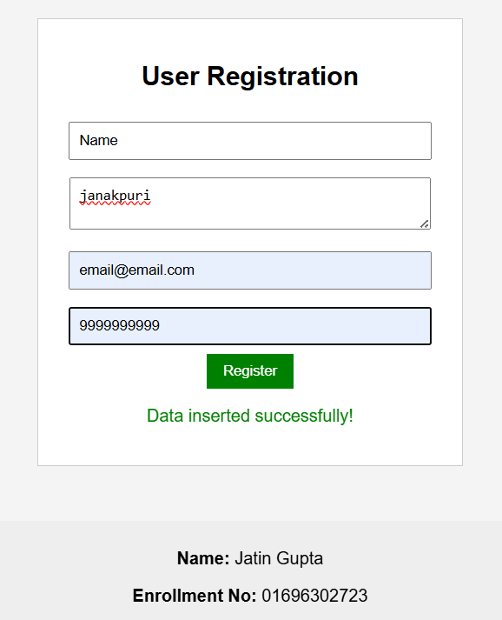

Display.php



